Sprint 0
Customer Intelligence & Sales Insights Platform (Snowflake)

Project Flow:
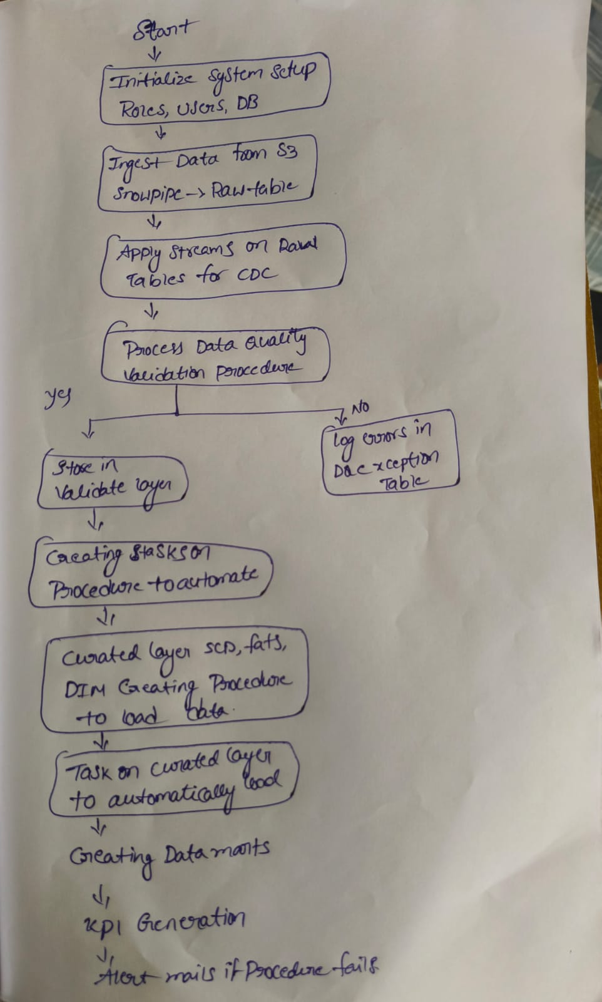
- Data ingestion from S3 using Snowpipe
- Change tracking using Streams
- Data validation and cleansing
- Transformation into curated schema (SCD2, facts, dimensions)
- Invalid data detection
- Data mart creation
- KPI generation and reporting
- Alert system for failures

Data Mart Design:

Dimension Tables
- dim_customer → SCD Type 2 (tracks history)
- dim_product → SCD Type 2
- dim_date → Time-based analysis
Fact Tables
- fact_sales → Transaction data
- fact_customer_activity → User behavior
- fact_customer_summary → KPI metrics

